Test Case: tc001_SPX_Dev5_Crear_Requisicion_Spot_Tipo_Cobro_CC
Step 1 - Enter username and password and click to button Enter : Credentials Entered
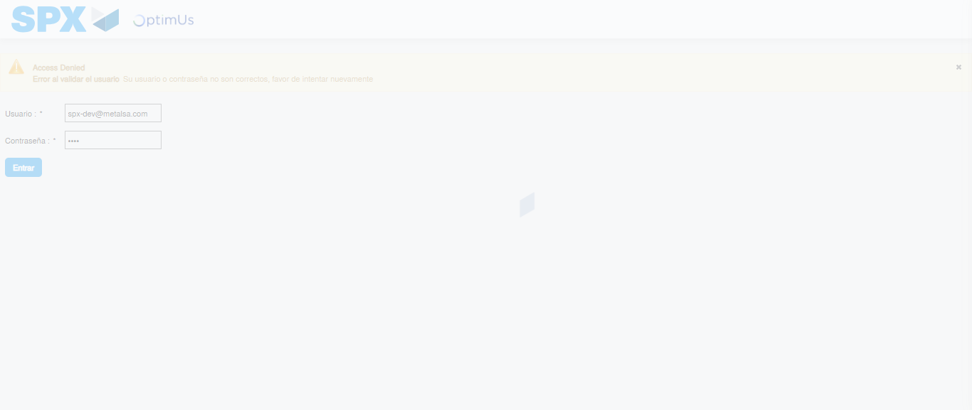Image file-name: QC_Testing-tc001_SPX_Dev5_Crear_Requisicion_Spot_Tipo_Cobro_CC-1790177094248

Step 2 - Select to UEN and Access to Spot Buy Requisitions : UEN Correctly selected and Correct access
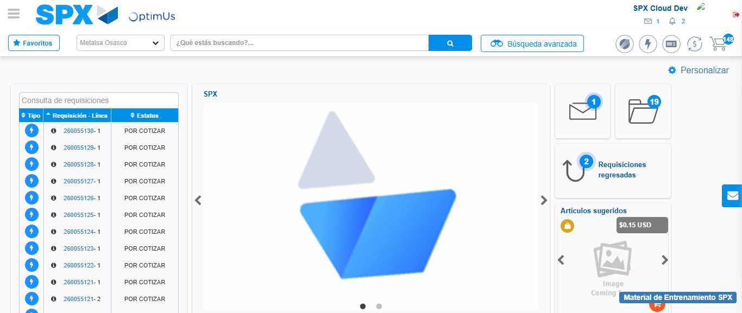Image file-name: QC_Testing-tc001_SPX_Dev5_Crear_Requisicion_Spot_Tipo_Cobro_CC-1790177117820

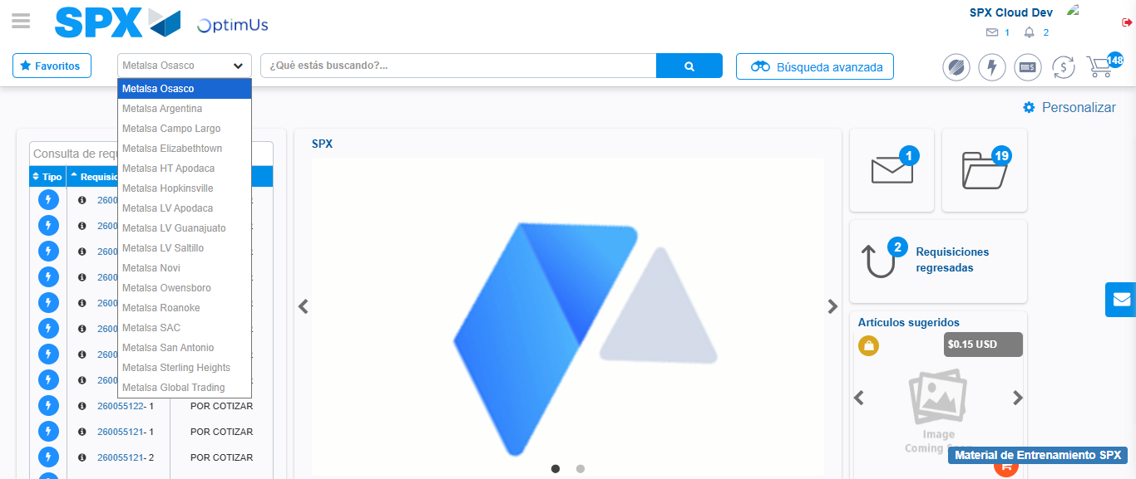Image file-name: QC_Testing-tc001_SPX_Dev5_Crear_Requisicion_Spot_Tipo_Cobro_CC-1790177118489

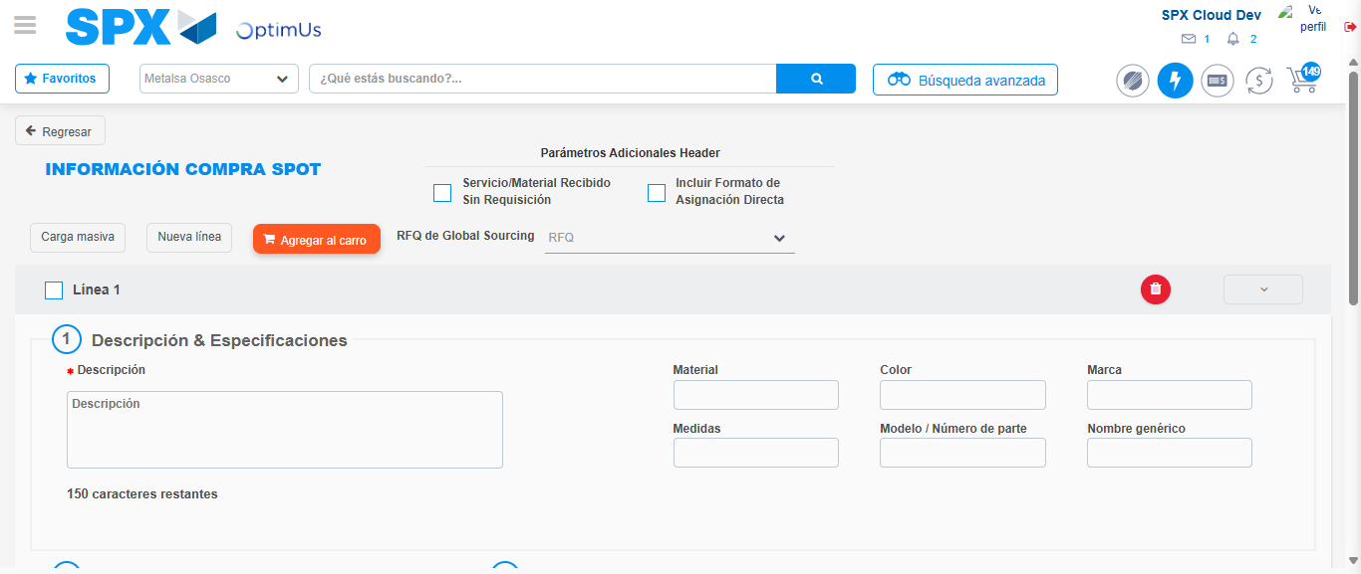Image file-name: QC_Testing-tc001_SPX_Dev5_Crear_Requisicion_Spot_Tipo_Cobro_CC-1790177138857

Step 3 - Data Capture Spot Buy Requisition : Data captured correctly
Image file-name: QC_Testing-tc001_SPX_Dev5_Crear_Requisicion_Spot_Tipo_Cobro_CC-1790177139150

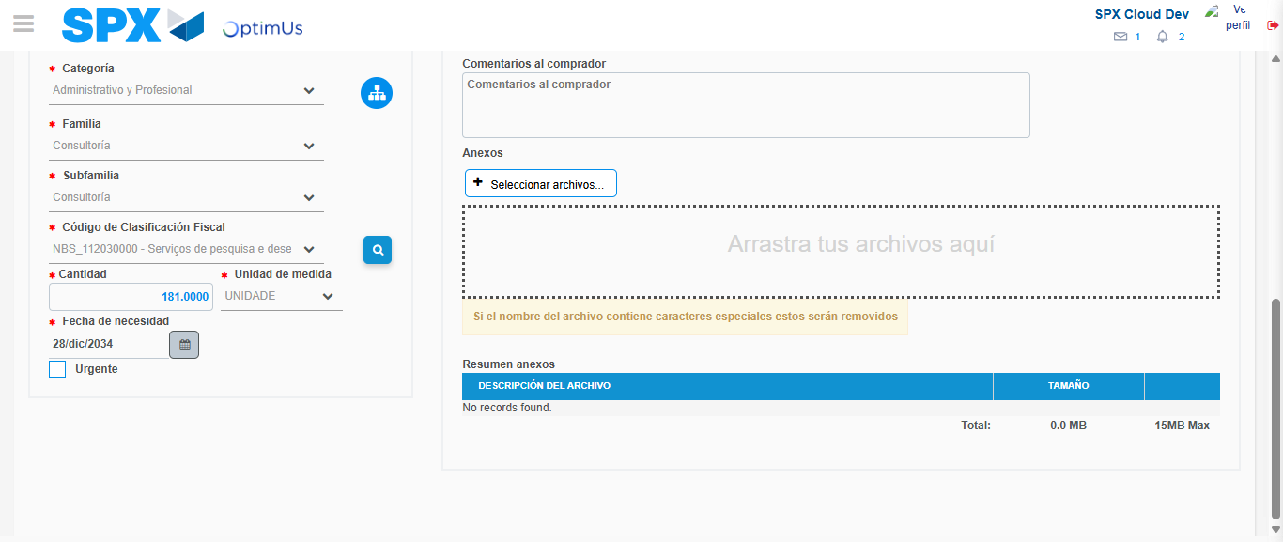Image file-name: QC_Testing-tc001_SPX_Dev5_Crear_Requisicion_Spot_Tipo_Cobro_CC-1790177165206

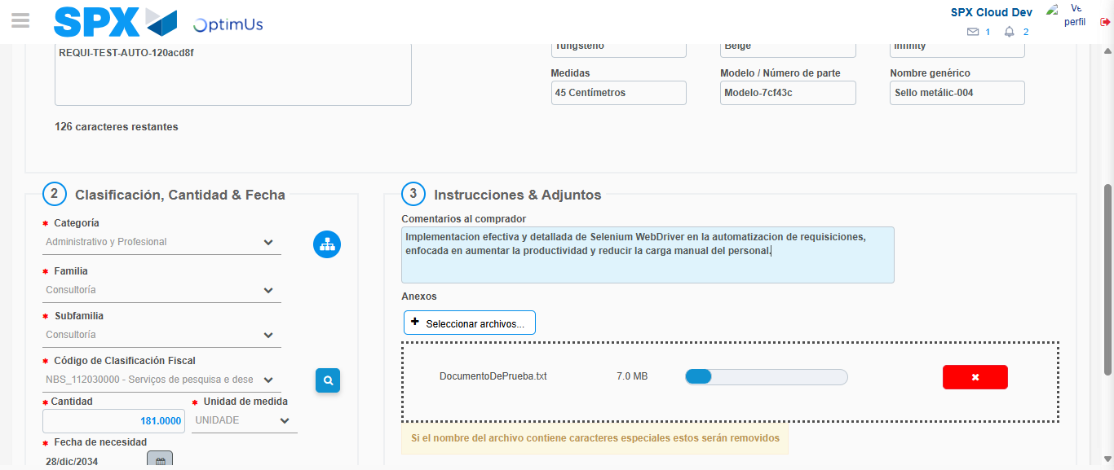Image file-name: QC_Testing-tc001_SPX_Dev5_Crear_Requisicion_Spot_Tipo_Cobro_CC-1790177166225

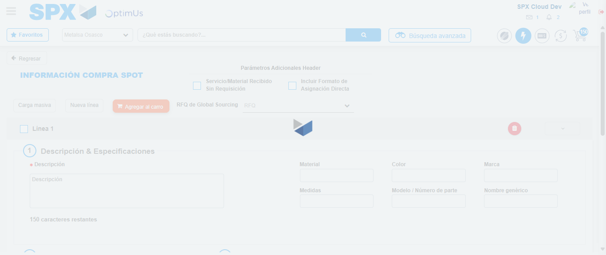Image file-name: QC_Testing-tc001_SPX_Dev5_Crear_Requisicion_Spot_Tipo_Cobro_CC-1790177167983

Step 7 - Return to Main Page SPX : Return to Main Page SPX
Image file-name: QC_Testing-tc001_SPX_Dev5_Crear_Requisicion_Spot_Tipo_Cobro_CC-1790177117820

Image file-name: QC_Testing-tc001_SPX_Dev5_Crear_Requisicion_Spot_Tipo_Cobro_CC-1790177118489

Image file-name: QC_Testing-tc001_SPX_Dev5_Crear_Requisicion_Spot_Tipo_Cobro_CC-1790177138857

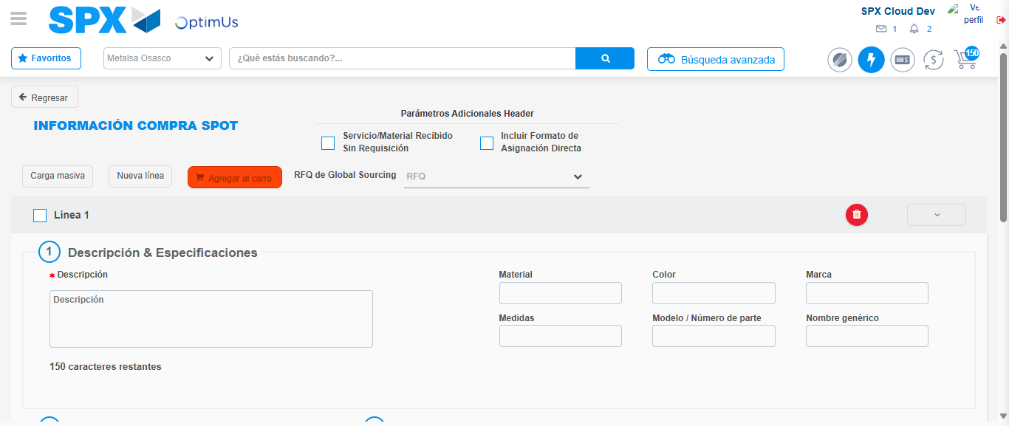Image file-name: QC_Testing-tc001_SPX_Dev5_Crear_Requisicion_Spot_Tipo_Cobro_CC-1790177170244

Image file-name: QC_Testing-tc001_SPX_Dev5_Crear_Requisicion_Spot_Tipo_Cobro_CC-1790177170404

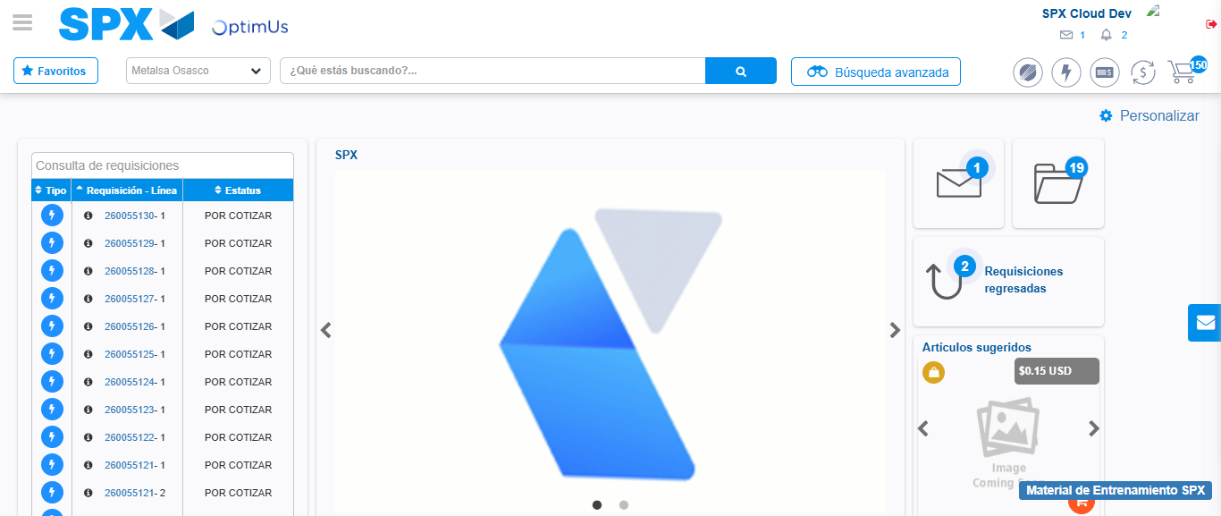Image file-name: QC_Testing-tc001_SPX_Dev5_Crear_Requisicion_Spot_Tipo_Cobro_CC-1790177191579

Step 8 - Log Out : Log Out SPX
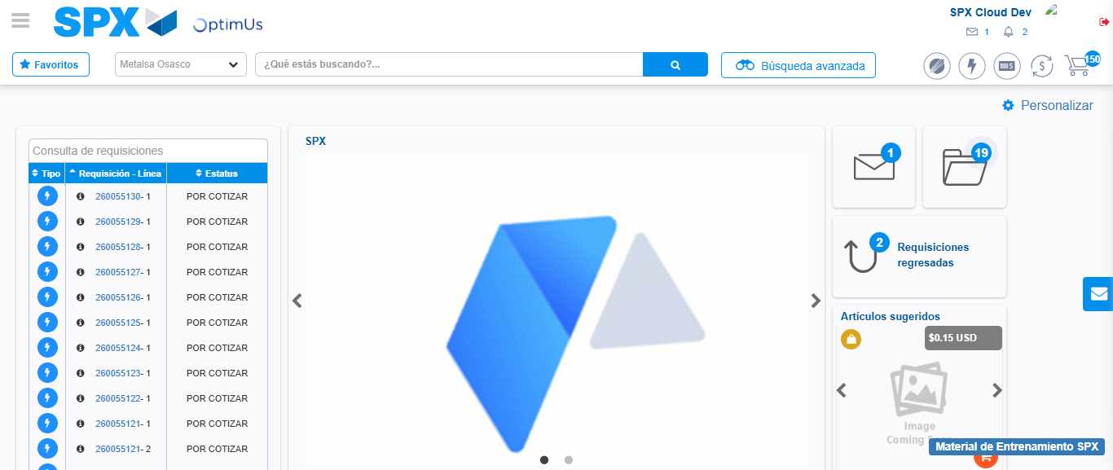Image file-name: QC_Testing-tc001_SPX_Dev5_Crear_Requisicion_Spot_Tipo_Cobro_CC-1790177191863

